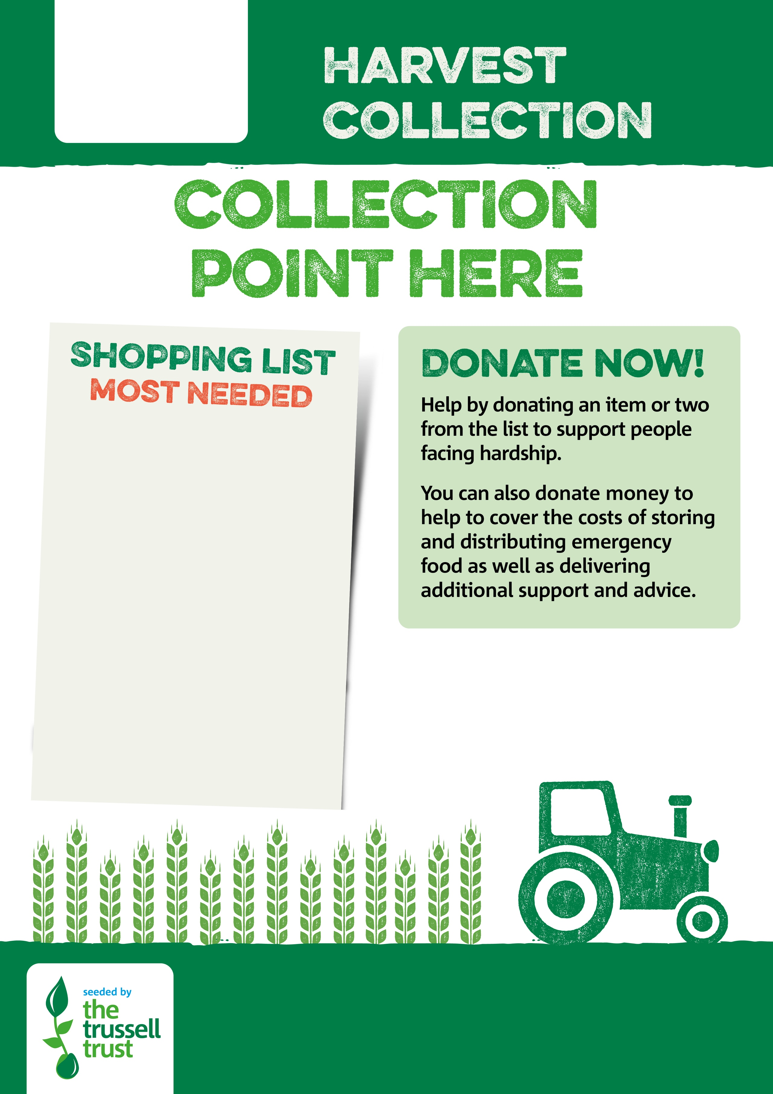

Tinned Corned Beef

Tinned Rice Pudding

Tinned Custard

Jam, marmite, peanut butter

Biscuits

Fruit Squash

Washing up Liquid

Laundry Detergent

Toilet Rolls

**https://strouddistrict.foodbank.org.uk/give-help/donate-money/**

Registered Charity in England & Wales 1176306